EXP-1
CODE:
#include <stdio.h>

int main() {
char s[50];
int k, i;

printf("Enter text: ");
scanf("%s", s);
printf("Enter k: ");
scanf("%d", &k);

for(i=0; s[i]!='\0'; i++)
s[i] = (s[i]-'A'+k)%26+'A';

printf("Encrypted: %s", s);
return 0;
}
OUTPUT:
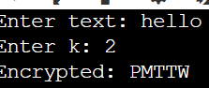
EXP-2
CODE:
#include <stdio.h>
#include <string.h>

int main() {
char p[] = "ABCDEFGHIJKLMNOPQRSTUVWXYZ";
char c[] = "QWERTYUIOPASDFGHJKLZXCVBNM";
char s[50];
int i;

printf("Enter text: ");
scanf("%s", s);

for(i = 0; s[i] != '\0'; i++)
s[i] = c[s[i] - 'A'];

printf("Encrypted: %s", s);

return 0;
}
OUTPUT:
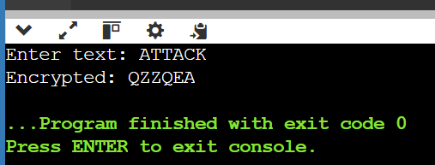
EXP-3
CODE:
#include <stdio.h>
#include <string.h>

int main() {
char s[100], key[]="MONARCHY", m[5][5];
int i,j,k=0,a,b,c,d;
char u[26]={0};

printf("Enter text: ");
scanf("%s",s);

for(i=0;key[i];i++)
if(!u[key[i]-'A'])
m[k/5][k++%5]=key[i],u[key[i]-'A']=1;
for(i=0;i<26;i++)
if(i!=9&&!u[i]) m[k/5][k++%5]='A'+i;

for(i=0;s[i];i+=2) {
if(!s[i+1]) s[i+1]='X',s[i+2]=0;
for(j=0;j<5;j++) for(k=0;k<5;k++) {
if(m[j][k]==s[i]) a=j,b=k;
if(m[j][k]==s[i+1]) c=j,d=k;
}
if(a==c) s[i]=m[a][(b+1)%5],s[i+1]=m[c][(d+1)%5];
else if(b==d) s[i]=m[(a+1)%5][b],s[i+1]=m[(c+1)%5][d];
else s[i]=m[a][d],s[i+1]=m[c][b];
}
printf("Encrypted: %s",s);
}
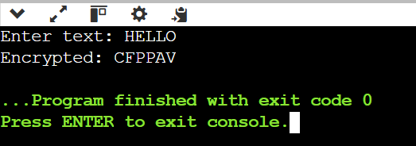
EXP-4
CODE:
#include <stdio.h>
#include <string.h>

int main() {
char s[100], key[100];
int i, n;

printf("Enter text: ");
scanf("%s", s);
printf("Enter key: ");
scanf("%s", key);

n = strlen(key);
for(i = 0; s[i]; i++)
s[i] = (s[i] - 'A' + key[i % n] - 'A') % 26 + 'A';

printf("Encrypted: %s", s);
return 0;
}
OUTPUT:
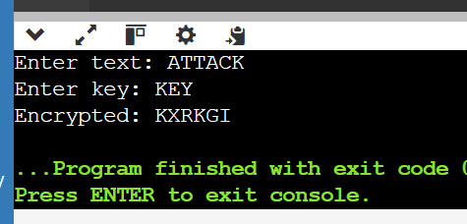
EXP-5
#include <stdio.h>
#include <string.h>

int main() {
char text[100];
int a, b, i, p, c;

printf("Enter plaintext: ");
scanf("%s", text);

printf("Enter a: ");
scanf("%d", &a);

printf("Enter b: ");
scanf("%d", &b);

printf("Ciphertext: ");

for (i = 0; text[i] != '\0'; i++) {
p = text[i] - 'a';
c = (a * p + b) % 26;
printf("%c", c + 'a');
}

return 0;
}
Output
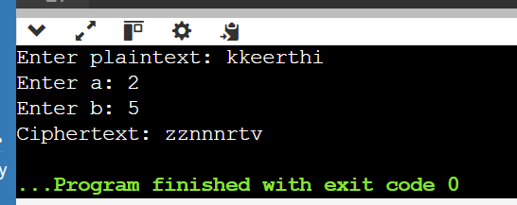
Exp-6
#include <stdio.h>
int main() {
int a, b, c, p;
printf("Ciphertext letters: B U\n");
printf("Try allowed values of a and b to decrypt.\n");
for (a = 1; a < 26; a += 2) {
if (a % 13 == 0) continue;
for (b = 0; b < 26; b++) {
if ((a * 4 + b) % 26 == 1 &&
(a * 20 + b) % 26 == 20)
printf("a=%d b=%d\n", a, b);
}
}
return 0;
}
Output
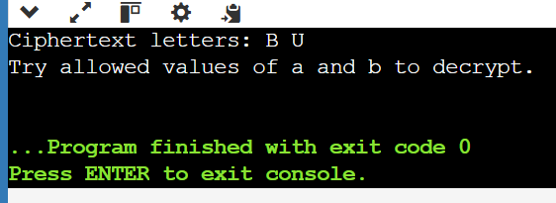
Exp 7
Code
#include <stdio.h>

int main() {
char c[] = "53‡‡†305))6*;4826)4‡.)4‡);806*;48†8¶60))85;;]8*;:‡*8†83";
int i, j, count;

printf("Ciphertext:\n%s\n\n", c);
printf("Character Frequency:\n");

for (i = 0; c[i]; i++) {
if (c[i] == ' ') continue;
count = 0;

for (j = 0; j < i; j++)
if (c[i] == c[j]) break;

if (j < i) continue;

for (j = 0; c[j]; j++)
if (c[i] == c[j]) count++;

printf("%c = %d\n", c[i], count);
}

return 0;
}
Output
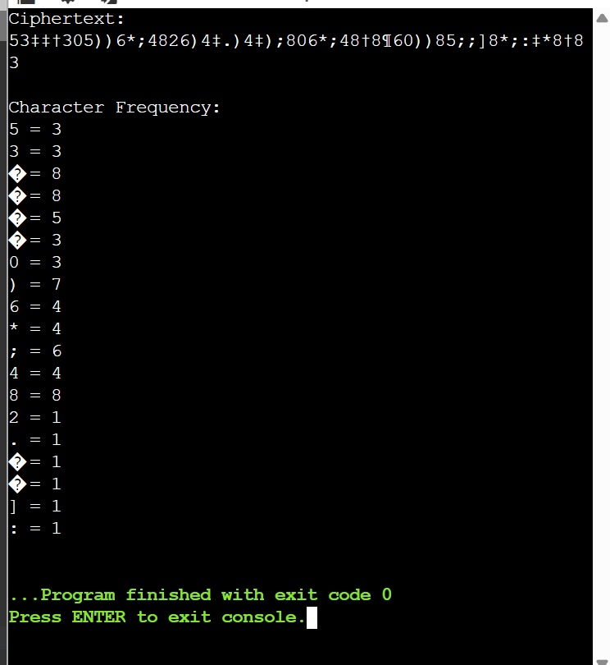
EXP 8
CODE

#include <stdio.h>
int main() {
char s[100], c[]="CIPHERABDGJKLMNOQSTUVWXYZ";
int i;
scanf("%99s", s);
for(i=0; s[i]; i++)
if(s[i]>='a' && s[i]<='z')
s[i]=c[s[i]-'a'];
printf("Ciphertext: %s",s);
return 0;
}
Output
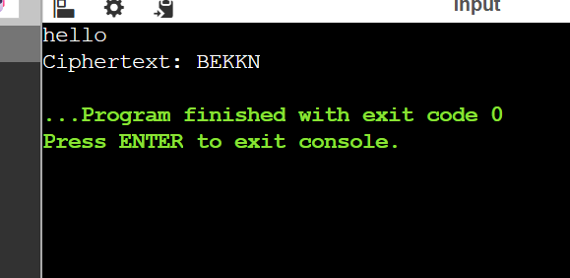
Exp-9
Code
#include <stdio.h>

char k[5][5]={{'R','O','Y','A','L'},{'N','E','W','Z','D'},
{'V','B','C','F','G'},{'H','I','K','M','P'},{'Q','S','T','U','X'}};
char s[]="KXJEYUREBEZWEHEWRYTUHEYFSKREHEGOYFIWTTTUOLKSYCAJPOBOTEIZONTXBYBNTGONEYCUZWRGDSONSXBOUYWRHEBAAHYUSEDQ";

int main(){
int i,j,r,c,x,y,a,b;
for(i=0;s[i];i+=2){
for(r=0;r<5;r++)for(c=0;c<5;c++){
if(k[r][c]==s[i])a=r,b=c;
if(k[r][c]==s[i+1])x=r,y=c;}
if(a==x)printf("%c%c",k[a][(b+4)%5],k[x][(y+4)%5]);
else if(b==y)printf("%c%c",k[(a+4)%5][b],k[(x+4)%5][y]);
else printf("%c%c",k[a][y],k[x][b]);
}
}Output
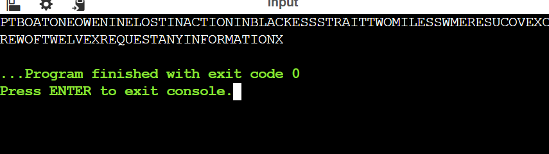
Exp-10
Code
#include <stdio.h>
#include <ctype.h>

char k[5][5]={{'M','F','H','I','K'},{'U','N','O','P','Q'},
{'Z','V','W','X','Y'},{'E','L','A','R','G'},{'D','S','T','B','C'}};

int main(){
char s[]="MUSTSEEYOUOVERCADOGANWESTCOMINGATONCE";
int i,a,b,c,d,r1,c1,r2,c2;
for(i=0;s[i];i+=2){
a=s[i]; b=s[i+1];
for(r1=0;r1<5;r1++)for(c1=0;c1<5;c1++){
if(k[r1][c1]==a)c=r1,d=c1;
if(k[r1][c1]==b)r2=r1,c2=c1;}
if(c==r2)printf("%c%c",k[c][(d+1)%5],k[r2][(c2+1)%5]);
else if(d==c2)printf("%c%c",k[(c+1)%5][d],k[(r2+1)%5][c2]);
else printf("%c%c",k[c][c2],k[r2][d]);
}
}
Output
